

***LAB REPORT***

***Khulna University of Engineering & Technology***

***Computer Science and Engineering***

***Name : Doniel Tripura***

***Roll : 1907121***

***Semester : 2nd***

***Subject : CSE 1202***

***Assignment : uva 100, uva 136, uva 494, uva 10038***



h

CSE Lab-> 2nd

|  |
| --- |
| //UVA 100  //USER ID: Doniel_121  //Online judge id: 1131325  #include<stdio.h>  int main()  {  int x,y;  while(scanf("%d %d",&x,&y)!= EOF)  {  int A,B,n,mx=0,i,j,count;  if(x<y) A=x,B=y;  else A=y,B=x;  if(A==0) A++;  for(i=A;i<=B;i++)  {  n=i;  count=1;  while(n!=1)  {  count++;  if(n%2!=0) n=3*n+1;  else n/=2;  }  if(mx<count) mx=count;  }  printf("%d %d %d\n",x,y, mx);  }  } |

|  |
| --- |
| //UVA 136  //USER ID: Doniel_121  //Online judge id: 1131325  #include<stdio.h>  int main()  {  int i,n,x,y,z,a,b,c,arr[2000],ans;  x=y=z=0;  arr[0]=1;  for(i=1;i<1500;i++)  {  a=2*arr[x];  b=3*arr[y];  c=5*arr[z];  if(a<b)  {  if(a<c)  {  ans=a;  }  else  {  ans=c;  }  }  else  {  if(b<c)  {  ans=b;  }  else  {  ans=c;  }  }  arr[i]=ans;  if(ans==a) x++;  if(ans==b) y++;  if(ans==c) z++;  }  printf("The 1500'th ugly number is %d.\n",ans);  } |

CSE Lab->3rd

|  |
| --- |
| //UVA 494  //USER ID: Doniel_121  //Online judge id: 1131325  //uva 495  #include<stdio.h>  #include<string.h>  int main()  {  char ch[100];  int i,count,word;  while(gets(ch))  {  count=word=0;  for(i=0;i<strlen(ch);i++)  {  if((ch[i]>='a' && ch[i]<='z') || (ch[i]>='A' && ch[i]<='Z')) word=1;  else count+=word, word=0;  }  count+=word;  printf("%d\n",count);  }  } |

|  |
| --- |
| //UVA 10038  //USER ID: Doniel_121  //Online judge id: 1131325  #include<stdio.h>  #include<string.h>  int main()  {  int n;  while(scanf("%d",&n)==1)  {  int i,j=0,a[n+1],d[n],mx,mn,t;  for(i=1;i<=n;i++)  {  scanf("%d",&a[i]);  }  for(i=1;i<=n;i++)  {  if(a[i]>a[i+1])  {  mx=a[i],mn=a[i+1];  }  else  {  mx=a[i+1],mn=a[i];  }  d[i]=mx-mn;  }  for(i=1;i<n;i++)  {  for(j=1;j<n;j++)  {  if(d[j]>d[j+1])  {  t=d[j],d[j]=d[j+1],d[j+1]=t;  }  }  }  int hudai=0;  for(i=1;i<n;i++)  {  if(d[i]!=i) hudai=1;  }  if(hudai==0) printf("Jolly\n");  else printf("Not jolly\n");  }  } |

Profile Name: Doniel_121

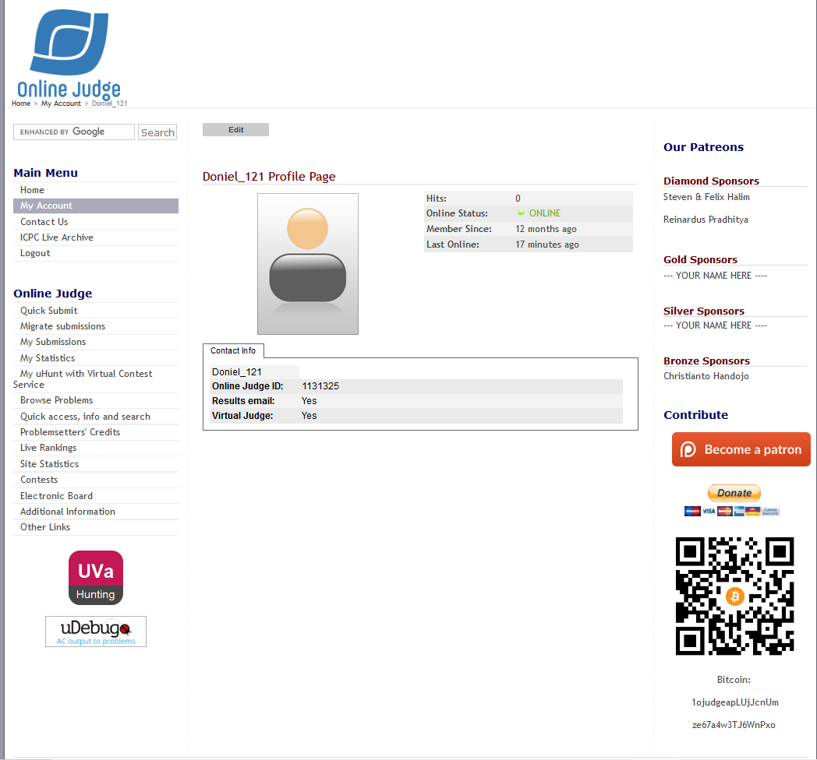

Profie link: https://onlinejudge.org/index.php?option=com_comprofiler&Itemid=3

|  |
| --- |
|  |